**Horizontal V/S Vertical Scaling**

Horizontal Scaling:

* Horizontal scaling refers to adding additional nodes or machines to your infrastructure to cope with new demands.
* If you are hosting an application on a server and find that it no longer has the capacity or capabilities to handle traffic, adding a server may be your solution.
* It is quite similar to delegating workload among several employees instead of one.
* We must decide which machine does what and how our new machines work with our old machines.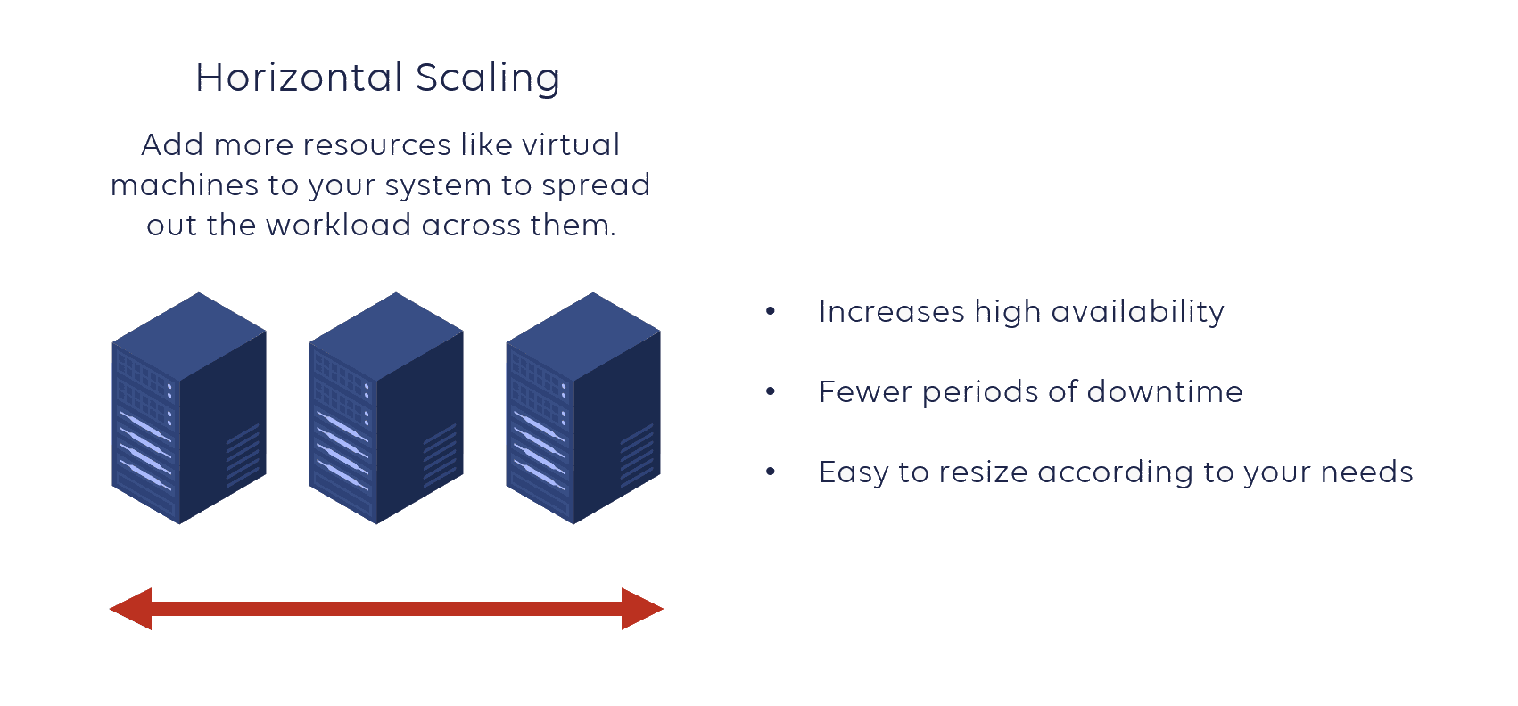

Vertical Scaling:

* Vertical scaling describes adding resources to a system so that it meets demand.
* In vertical scaling refers to upgrading of CPU, Memory, storage and network speed.
* Vertical scaling may also describe replacing a server entirely or moving a server’s workload to an upgraded one.

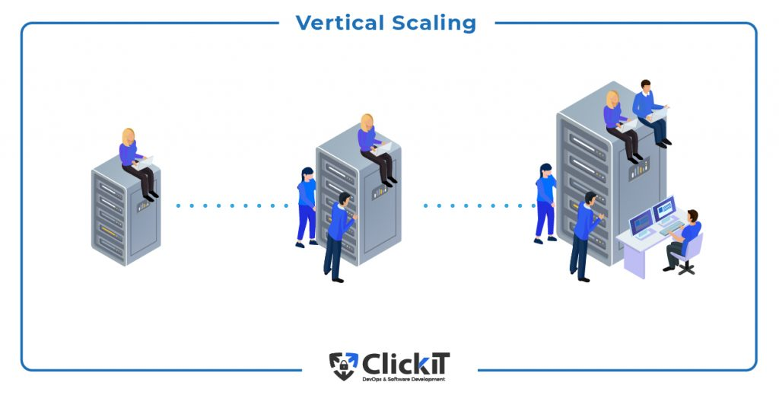

Difference:

* Horizontal scaling means scaling by adding more machines to your pool of resources.
* Whereas vertical scaling refers to scaling by adding more power to an existing machines.
* One of the fundamental difference between the two is that horizontal scaling requires breaking a sequential piece of logic into smaller pieces, so that they can be executed in parallel across multiple machines.
* In many respects, vertical scaling is easier because the logic really doesn’t need to change.
* Rather, you’re just running the same code on higher spec machines.

